From: https://davidstockmanscontracorner.com/irrational-malfeasance-on-steroids/

Irrational Malfeasance On Steroids
By David Stockman. Posted On Thursday, January 2nd, 2020
Of course it makes sense. Not!
The S&P 500 opened the new year and decade at 3258 or 37% above the Christmas Eve lows of 2018 and 23% above the level of March 2018 (2640). The latter occurred at a time when the corporate tax cut sugar high was cranking through the GDP statistics and before the Donald had launched his $79 billion tariff bludgeon against $360 billion of Chinese imports.
That is, since March 2018 the incoming domestic data has steadily weakened, the Trade War has gotten a lot worse and global trade and PMIs have literally punched through the flat-line. So it ain't prospective growth and profit gains which are levitating the stock markets.
Year-Over-Year Change In Global Trade Volume
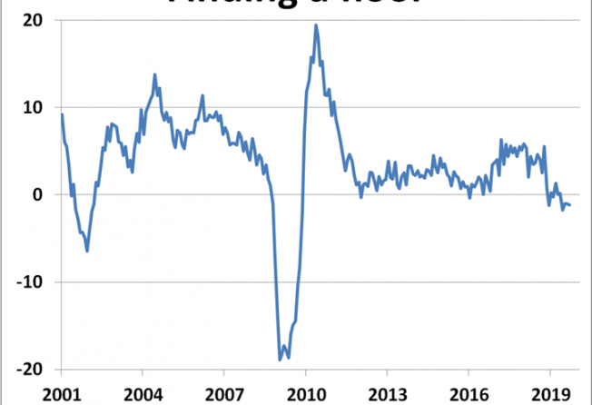
But we revert to the March 2018 date for a reason. Namely, at that point the hockey-stick crowd on Wall Street was predicting "operating" earnings of $172.62 per share for 2019, thereby valuing expected year-forward earnings at 15.3X.
Forgive our cynicism, but like clockwork the Wall Street analyst consensus on a one year-forward earnings basis always reflects a 15X PE ratio. The fly in the ointment, however, is that the "E" almost never materializes, and this time was no exception.
With three quarters in the bag and Q4 earnings just around the corner (and therefore already cut by 11.3% from the March 2018 consensus), it now appears that 2019 earnings will struggle to reach $158 per share. That is, the S&P 500 index is up 23% from March 2018---even as estimated earnings for the year have dropped by 8.5%.
Needless to say, there is only one way to square that circle: Wall Street has once again made up for dwindling "E" with a pumped up multiple. In fact, at today's close the PE multiple is up by 34% from its 21 months ago level to 20.6X.
But as they say on late night TV, there's more. The current 20.6X PE is derived from so-called "ex-items" earnings, or the kind that CEOs and CFOs go to jail for if they file such adjusted and manipulated numbers with the SEC.
At the current moment in time, the actual GAAP LTM figure for September 2019 is just $132.90 per share and the street's GAAP estimate for the full year will be lucky to hold at $140 per share. So in the real world the broad market opened the Turbulent Twenties at somewhere between 23.5X and 24.5X honest-to-goodness GAAP profits.
At any time in the business cycle that ain't even close to cheap, but at month #127 of history's most tepid and unsustainable recovery, it's downright absurd.
Once upon a time, the stock market was a discounting machine and stock prices reflected all that was known, feared, imagined, hoped for and divined among millions of market participants. But today it all reduces to a single variable: Namely, the money-pumping actions of the Fed and other central banks.
Indeed, the latter is the only thing that has changed for the "better" since the above mentioned dates in 2018. Back then the Fed was finally on a normalization path with periodic rate increases expected at least through 2018 and 2019; and the Fed's belated balance sheet shrinkage operation, which finally commenced in October 2017, was purported to be on "automatic pilot" as per Powell's very own "read my lips" equivalent.
Needless to say, the 19.9% stock market drawdown of late 2018 vaporized whatever shred of backbone still existed in the Eccles Building, and the Oval Office, too. Trump quasi-surrendered on his Trade War, while the Fed heads jettisoned any remaining pretense of either backbone or brains.
Not only did it cut rates three times back to a funds rate of 1.55% or essentially 80 basis points below the LTM inflation rate (16% trimmed mean CPI), thereby gifting the Wall Street carry traders yet again, but it literally flooded the bond pits with such malice aforethought as to cause even the Bernank to blush.
As shown below, during the final 105 days of 2019, the Fed pumped up its balance sheet by the staggering sum of $405 billion, purchasing $170 billion of "not QE" T-bills and adding another $235 billion of TOMOs (temporary open market operations via overnight and short-term repos), which all except the lobotomized talking heads of bubble vision recognize to actually be POMOs (permanent open market operations).
Folks, POMOs are Fedspeak for money printing and monetizing the public debt. And on an annualized basis it is now occurring at a $1.4 trillion rate!
Since that exceeds even the frenzied money-pumping of 2008-2009, the question recurs: How is it that the casino gamblers have re-rated the market PE upwards by 34% to the veritable nosebleed section of history, while the Fed is pumping money like there is no tomorrow?
The short answer is mindless ritual incantation, not the claim that the geniuses in the Eccles Building have discovered a rat in the money market plumbing and have been quietly working to dispatch it.
Actually, these half-wits are so fixated on enforcing their idiotic Fed funds target at 1.55%, that they have become the monetary equivalent of baby seal hunters bearing clubs.
The central banking folly pictured in the graph is owing to the fact that their Fed funds target relates to a vestigial market indicator that Bernanke & Co destroyed more than a decade ago. Today the Federal funds market trades practically by appointment with daily volumes of hardly $50 billion, and most of that is accounted for by the rather pointless cash management operations of the Federal Home Loan Banks.
On the other hand, the real money market includes the multi-trillion tri-party repo system, commercial paper and other short-term unsecured credit markets, and taken together it is upwards of $5-$10 trillion in size in the US alone.
And by the true and inescapable economics of fungibility and arbitrage, any excess of demand anywhere in this vast system will give rise to short term rate spikes, which is exactly why the repo ruction occurred during mid-September.
So call it Whack-A-Mole or clubbing baby seals or what you will. But the very idea that 1.55% has to be enforced to the second decimal place across multi-trillion money markets amounts to Irrational Malfeasance on Steroids.
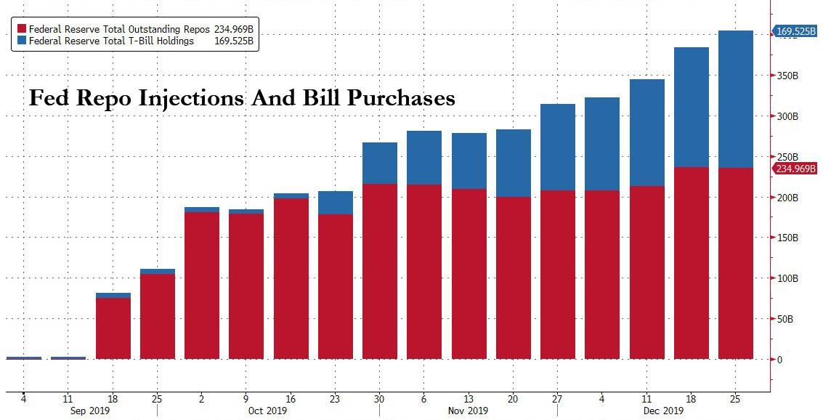
Of course, there is a very good reason why the Fed has found itself beleaguered by uncooperative, squealing baby sells. To wit, the fiscal departments of Washington have been spending and borrowing with reckless abandon.
Just since June 30, the US Treasury under the watch of the King of Debt has issued more than $900 billion of new borrowings. That's $5.3 billion per day including weekends, holidays and snow days.
Needless to say, this tsunami of Treasury paper has caused the balance sheets of the 23 official government bond dealers to balloon big time, sending them, in turn, into the repo market for funding. As our colleague Lee Adler cogently described it:
They know damn well why it happened. The only way the market could finance all that Treasury issuance was through repo borrowing. That, folks, is margin debt plain and simple. The dealers and the banks were buying up Treasury issuance on 90% margin. In September, they said, No mas! They’d had enough.
I have shown you this chart before. The banks had been expanding their repo borrowing at an annual rate of an astounding 40% to 60% throughout 2019, and that was on top of a 20% growth rate in 2018. Their repo borrowings rose from the $350-400 billion range in 2017 to $850 billion at the peak in September.
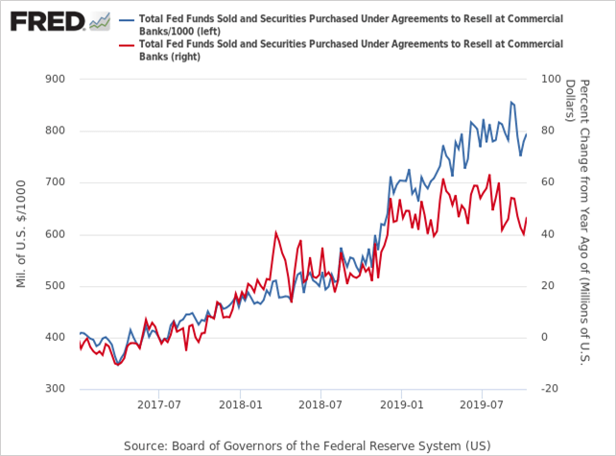
On top of that, of course, the hedge funds and other Wall Street speculators never miss a beat. Seeing the Fed's panicked roll-out of new funding facilities---"not QE" or otherwise---they have gone into overdrive front-running the Fed's renewed spree of balance sheet expansion. That is, they have been putting on structured trades in treasuries and futures expecting their value to be lifted by the Fed's new burst of securities absorption while financing them on 90% margin in the repo market.
Back in the day, of course, no one would have been surprised about the consequence of this massive jam-up in the repo market. The pricing mechanism would have been called-upon to do its job---with sharply rising yields at once discouraging demand and inducing new supply into the market.
But, alas, the Fed heads pulled a Capt. Renault back in September, professing to be shocked, shocked when term repo rates spiked to 10%, and were still posting at 3-4% for term borrowings in the run-up to the year-end "turn".
Needless to say, these spikey overnight and multi-week trades between consenting adults had not been permissioned by the Fed, and that it could not abide.
So it mounted ever larger repo facilities and T-bill purchases for the purpose of smashing yields---even though that was virtually a fraudulent rigging of the money and debt markets.
Yet by offering freshly minted cash against literally any and all UST collateral that moved or stood still, it did finally force traders to toe the mark exactly at its target policy rate.
For the moment, it appears, all the baby seals have been clubbed senseless. As the markets opened on this new year and new decade, the overnight repo rate fell in line at 1.58%.
But this is surely a pyrrhic victory if there ever was one.
The little fury lemmings in the stock market have gone manic on the Fed's monetary drugs and are literally racing toward the cliff. At some point soon even the mad money-printers in the Eccles Building will be powerless to stop the carnage.
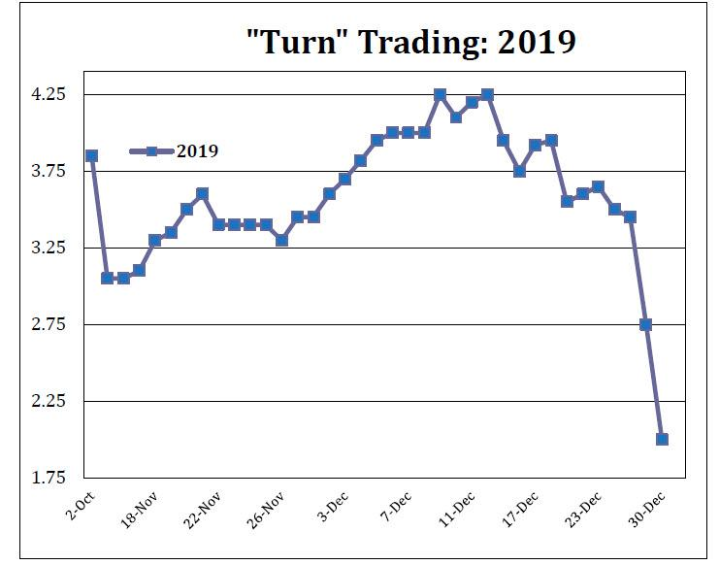
And there will truly be carnage. For instance, there has never in history been a fiscal pattern like the one shown below. The Fed's Irrational Malfeasance has not only fueled a blow-off top on Wall Street, but has also completely euthanized the politicians on both end of Pennsylvania Avenue with respect to the fiscal equation.
When the crash comes and the C-suites again throw workers and assets overboard with reckless abandon, there will be no stopping the surge of budgetary red ink during the ensuing recession. And this time there will be multi-trillion annual deficits as far as the eye can see because the Fed will be out of dry powder and powerless to reverse the tide.
